Hands On International Volunteer Trip to Puerto Rico.
A great opportunity for Rotarians to actively participate in a service project.
The Medford Rogue, Jacksonville-Applegate and Reedsport Rotary Clubs have secured funding ($18,000) to purchase 300 water filtration system components for families in Puerto Rico and many members of our clubs are planning to travel to Puerto Rico to help assemble and distribute these filters.
The primary purpose of this trip is to improve the health of Puerto Rican children, youth, and adults in the Yabucoa and Caguas communities. Water borne diseases, bad sanitary conditions, and lack of access to medical care are elements that are affecting the lives of rural families in Puerto Rico, still recovering from massive hurricane damage and the covid epidemic. This project will provide microfiber water filters (designed to last 10 years and to filter 1 million gallons before replacement) for 300 families.
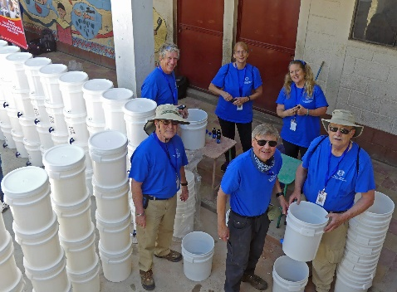
Members of our clubs, friends and families have travelled to Guatemala with Jorge as our team coordinator on five similar trips to assemble and deliver water filters. As we have discovered, international travel to help the less fortunate access clean water has two benefits to club members. One is the satisfaction of service and the other is the generation of enthusiasm for international work that members bring back to our club.
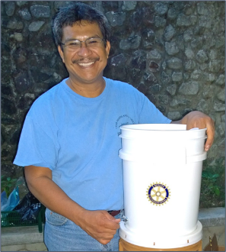
Travel with Woodland Charities is incredibly easy. You send a check to cover the room, board and transportation, and buy your plane ticket. You are picked up at the airport in San Juan, stay in a hotel, eat in restaurants, travel by bus, work hard and have plenty of time for experiencing the local community.
Rotarians in District 5110 would love the experience.
Would you be interested in joining us?
Our Team Coordinator for this trip is a fellow Rotarian and the Executive Director of Woodland Public Charity, Jorge D. Coromac, who will take care of our every need.
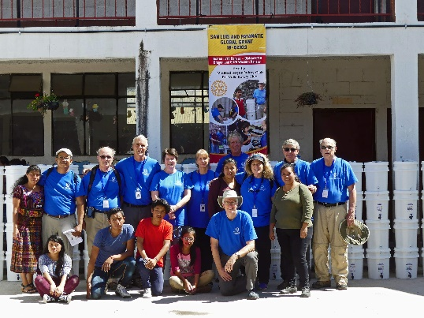
Duration and cost of the trip:
(tax deductible)
Includes in-country expenses: meals, lodging, ground transportation, translators, program administration expenses and evacuation insurance. Volunteers are responsible for purchasing their own roundtrip airplane ticket from the U.S.

* Please do not purchase your airplane ticket until approved by the team coordinator.

Apply at the Woodland Charity Website: www.woodlandcharity.org
(Don’t wait – applications due January 7)

